EC_PRA_SD_CM10003 (VLA1553L)

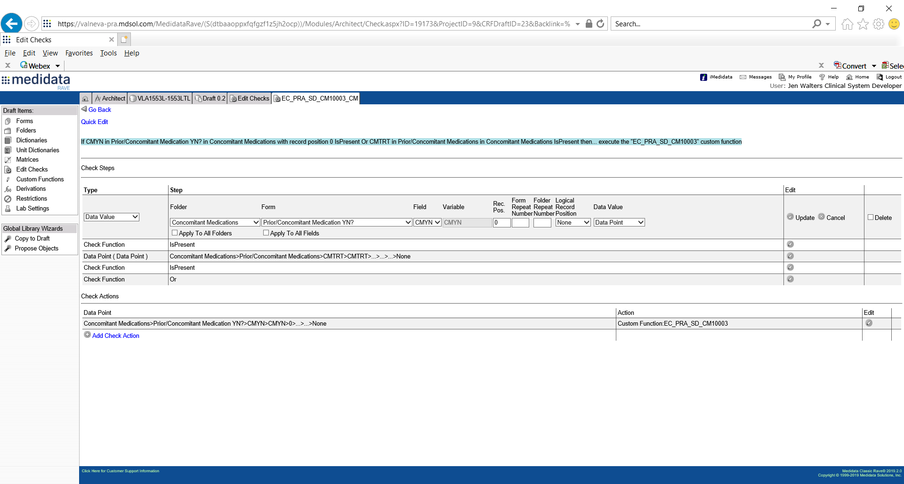

There are 3 versions of interface check actions? 1 with just 1 check step (cmyn is present), 2 with 2 OR check steps (cmyn is present, cmtrt is present) , (cmyn is present, dses is present)?? All – datapoint defined.